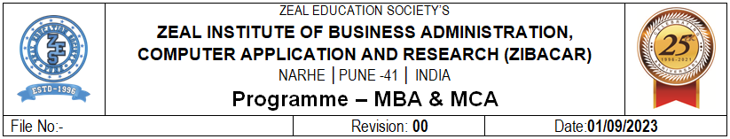
Q1. Perform Following Filter Operation on Superstore Dataset
- Display Top 5 Customers based on Sales.
- Show products having sales greater than ₹50,000 (Condition Filter).
- Display customers whose names start with "A". Wildcard Filter
- Find Top 10 Products in the Technology Category.

Steps : a) Display Top 5 Customers based on Sales.

- Open Tableau → connect to the Superstore dataset.
- Go to a new Worksheet.
- Drag Customer Name → Rows.
- Drag Sales → Columns.
- Click the Customer Name drop-down on Rows.
- Select Filter.
- Go to the Top tab.
Select:
- By field
- Top: 5
- Sum of Sales
- Click OK.
- Sort the chart descending using the sort icon.

Output :

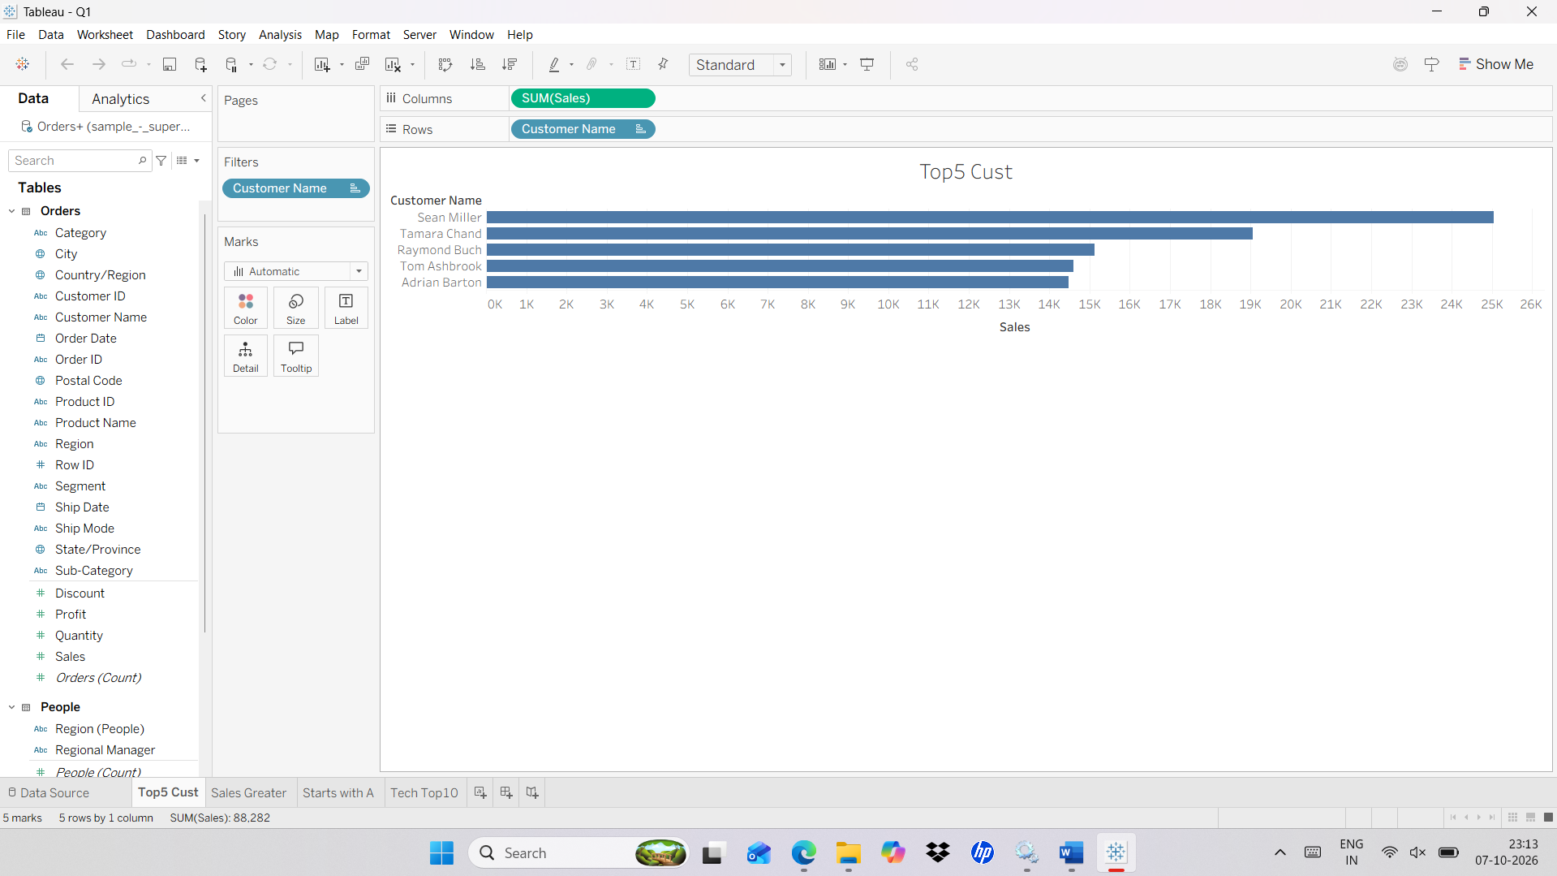

Steps : b) Show products having sales greater than ₹50,000 (Condition Filter).
- Create a new worksheet.
- Drag Product Name - Rows.
- Drag Sales - Columns.
- Drag Product name again - Filters.
- In the filter window Select condition filter
- Select by field
- Set the condition to: SUM(Sales) > 50000
- Click OK.
Output:
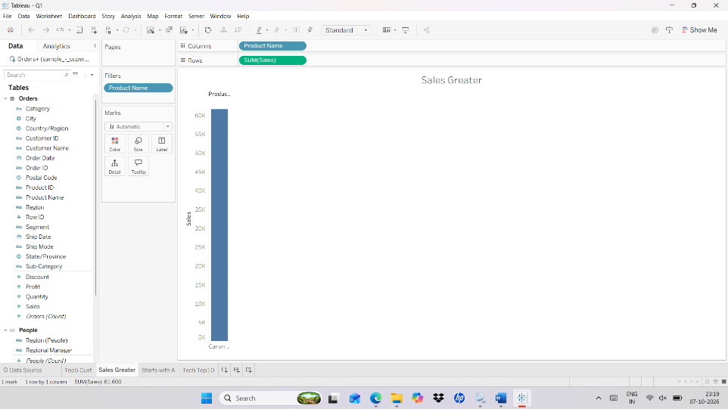

Steps : c) Display customers whose names start with "A". Wildcard Filter

- Create a new worksheet.
- Drag Customer Name - Rows.
- Drag Customer Name - Filters.
- In the Filter window, select the Wildcard tab.
- Select Matches pattern.
- Enter: A
- Click OK
Output :

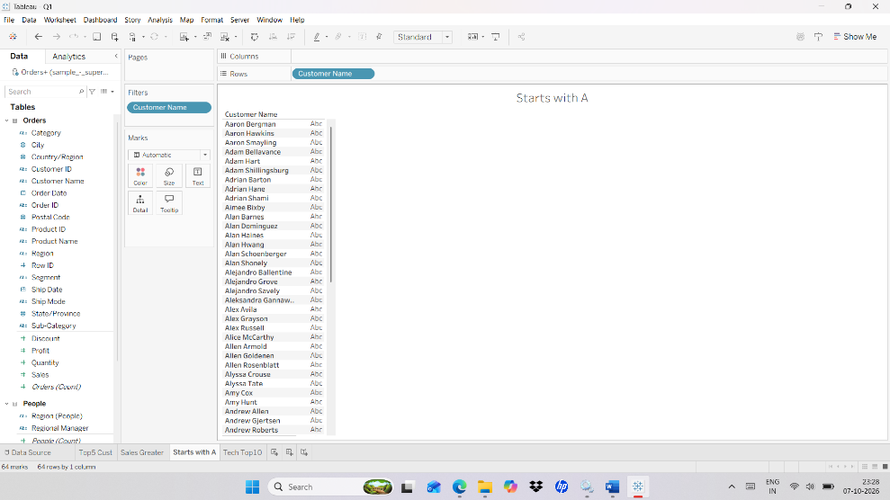

Steps : d) Find Top 10 Products in the Technology Category.

- Create a new worksheet.
- Drag Product Name - Rows.
- Drag Sales - Columns.
- Drag Category - Filters.
- In the filter window select only: Technology
- Click Category in filter pane and select “Add to Context”
- Click OK.
- Drag Product name – Filters
- In the filter window select Top tab
- By field
- Top: 10
- Sum of Sales
- Click OK

Output :
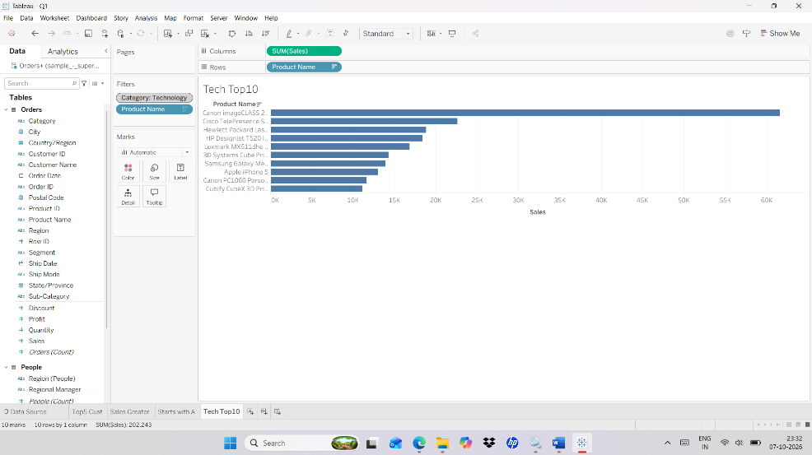

Q2. Perform Following Sorting Operation on Superstore Dataset.
- Arrange Sub-Categories from highest sales to lowest sales.
- Sort States based on Profit.
- Sort Sales in Descending Order based on product.
- Arrange customer names in ascending alphabetical order.
Steps : a) Arrange Sub-Categories from highest sales to lowest sales.

- Drag Sub-Category to Rows.
- Drag Sales to Column.
- Right-click Sub-Category on the Rows.
- Select Sort.
- Under Sort By, select Field.
- Set:
- Order: Descending
- Field: Sales
- Aggregation: Sum
- Click OK.

Output :

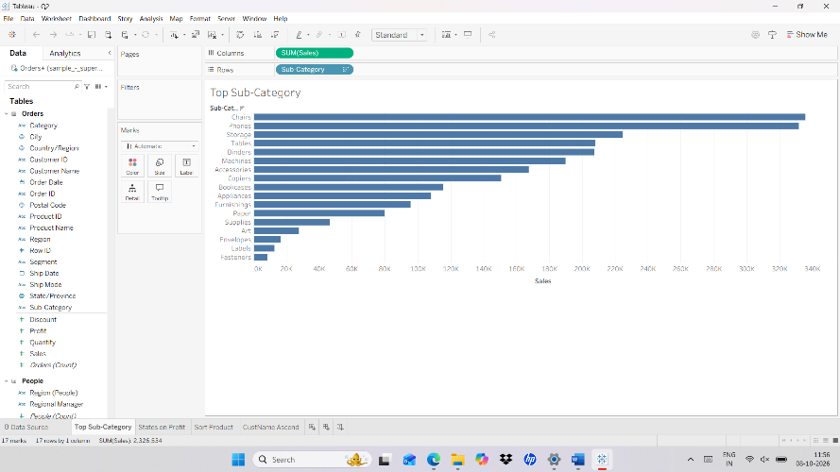

Steps : b) Sort States based on Profit.
- Create a new Worksheet.
- Drag State → Rows.
- Drag Profit → Columns.
- State → Sort → Sort By → Field → Descending → SUM(Profit)
- Click OK.
Output :
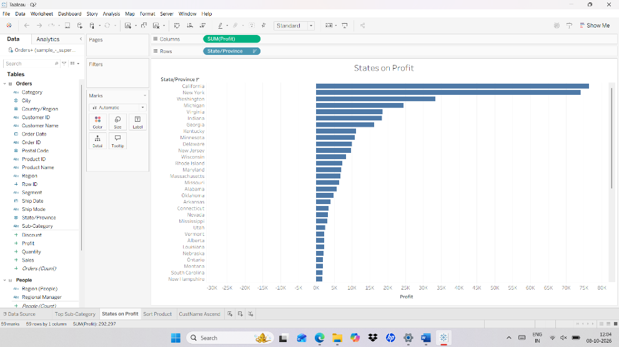

Steps : c) Sort Sales in Descending Order based on product.

- Create a new Worksheet.
- Drag Product Name → Rows.
- Drag Sales → Columns.
- Right-click Product Name.
- Select Sort.
- Choose:
- Sort By: Field
- Order: Descending
- Field: Sales
- Aggregation: Sum
- Click OK.

Output :

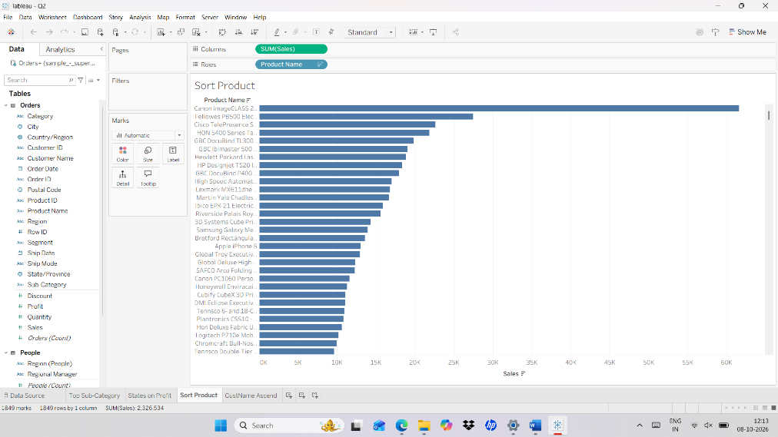

Steps : d) Arrange customer names in ascending alphabetical order

- a new Worksheet.
- Drag Customer Name → Rows.
- Right-click Customer Name on the Rows shelf.
- Select Sort.
- Under Sort By, select:
- Alphabetic
- Under Order, select:
- Ascending (A-Z)
- Click OK.

Output :

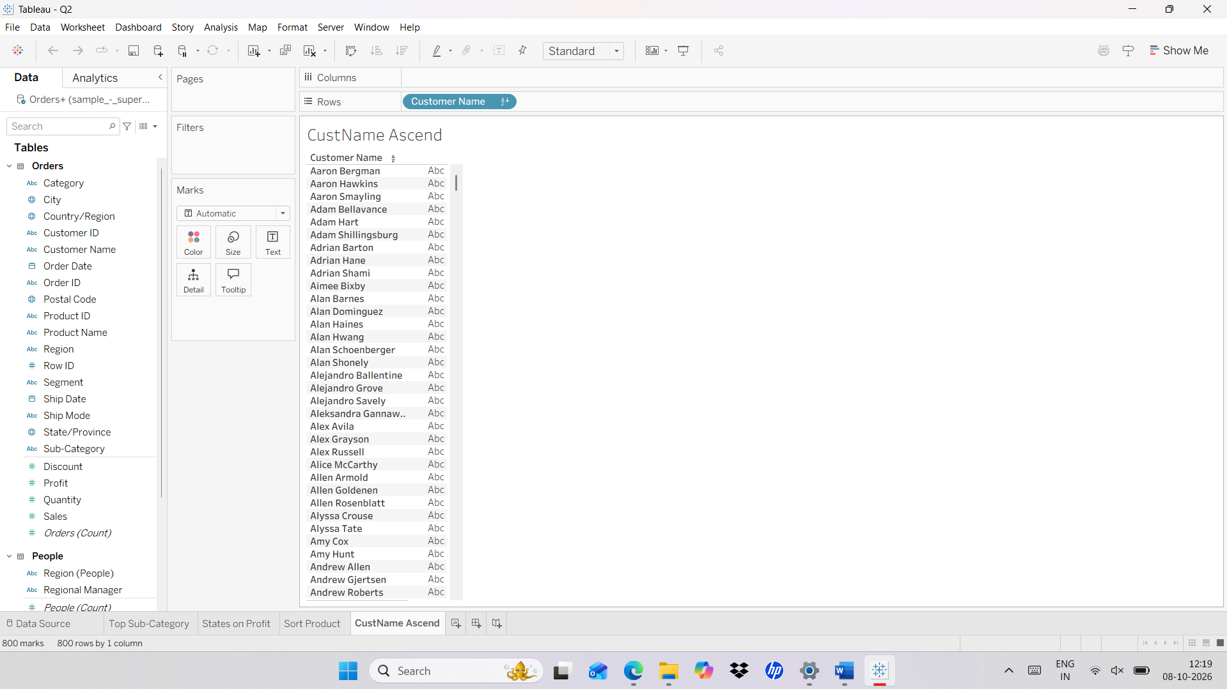

Q3. A) Use FMCG_sales_dirty.csv data source.
- Find missing values in the Sales field and replace them with an appropriate value.
- The Product field contains inconsistent capitalization and unnecessary spaces. Clean the product names.
Steps : a) Find missing values in the Sales field and replace them with an appropriate value.
- Go to a new Worksheet.
- Create Calculation Field – AVG([sales]) – Drag to the sheet.
- Now create another Calculation Field - IF ISNULL([Sales]) THEN 14877 ELSE [Sales] END

Output :
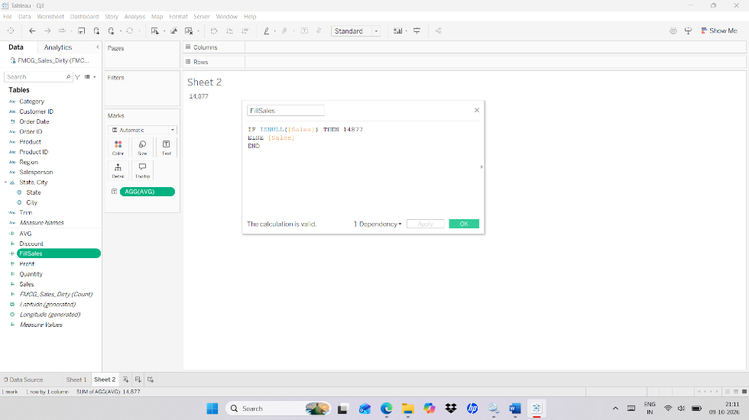

Steps : b) The Product field contains inconsistent capitalization and unnecessary spaces. Clean the product names.
- Go to a new Worksheet.
- Create Calculation Field – TRIM([sales])

Output :
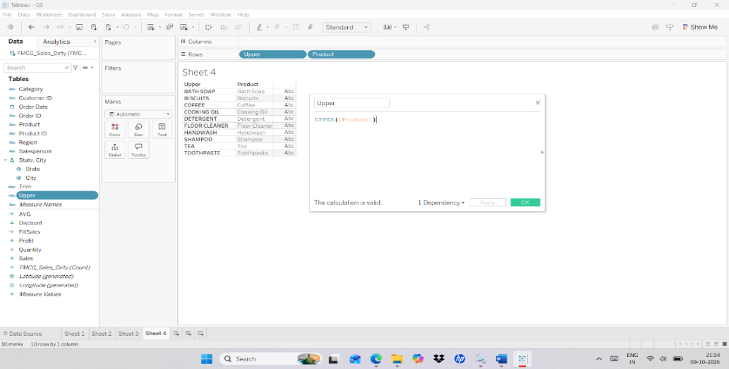

Q4. ) Use FMCG_sales_dirty.csv data source.
    - Identify inconsistent category names such as Beverage, beverage, BEVERAGES, etc., and create a standardized category field.
b) Find negative values record from quantity and sales convert to positive values with ABS().

Steps : a) Identify inconsistent category names such as Beverage, beverage, BEVERAGES, etc., and create a standardized category field.

- Go to a new Worksheet.
- Create Calculation Field – UPPER(TRIM([Category]))

Output :
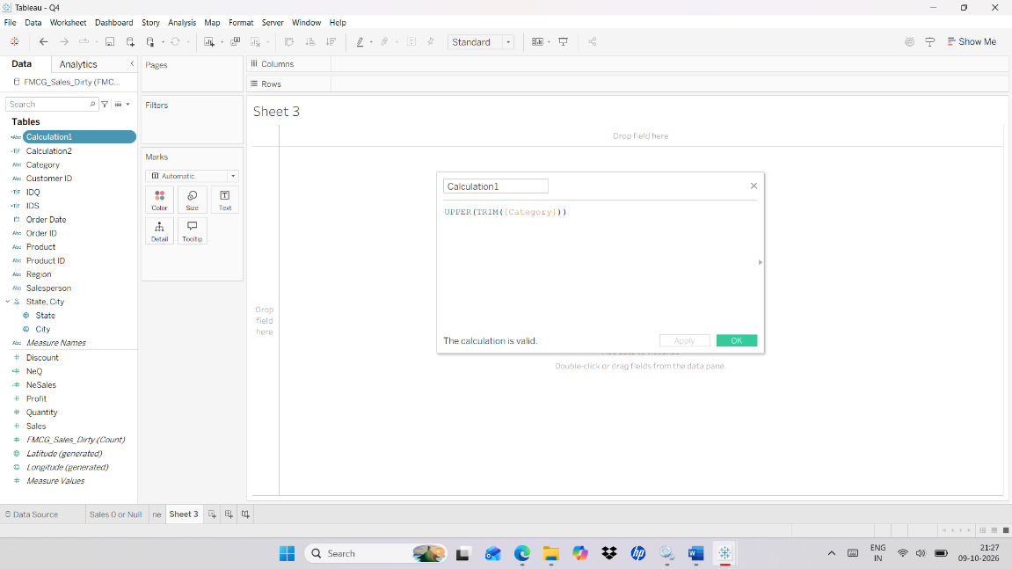

Steps : b) Find negative values record from quantity and sales convert to positive values with ABS().

- Go to a new Worksheet.
- Create Calculation Field – ABS([Sales]) and ABS([Quantity])

Output :

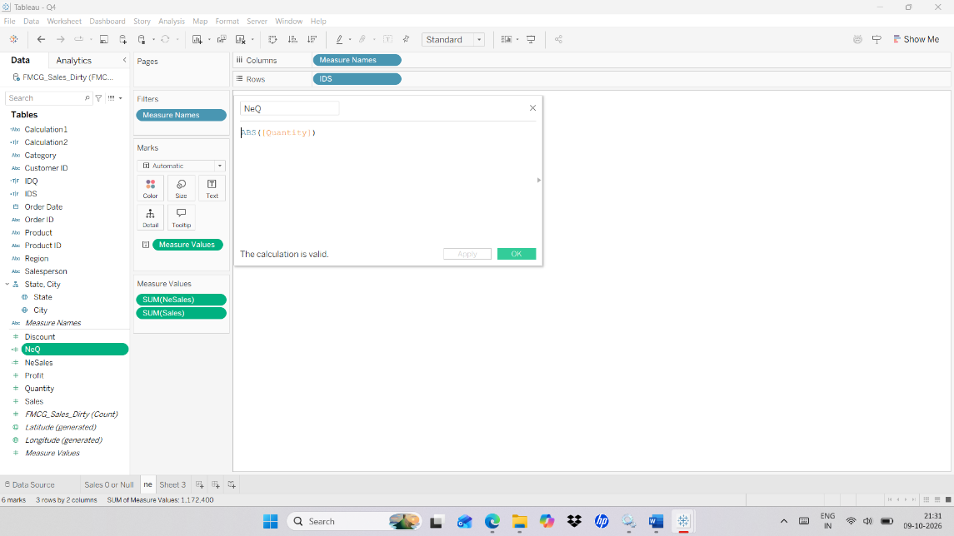

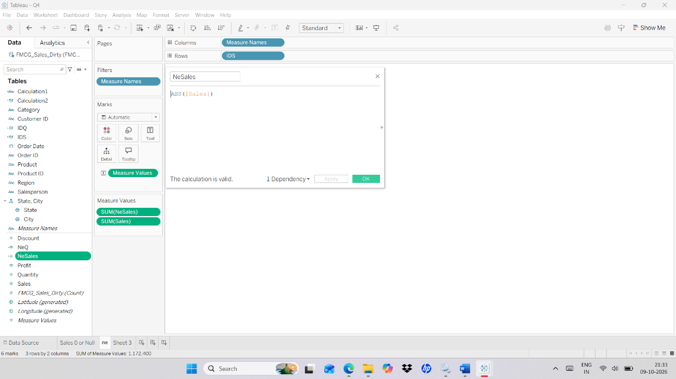

Q5. Join the Orders and Returns tables and identify which orders were returned.
Steps :
- Create New Worksheet
- In data source join Orders and Return table.
- Drag Order ID and Order Date to rows
- Drag Returned to Text.
Output :
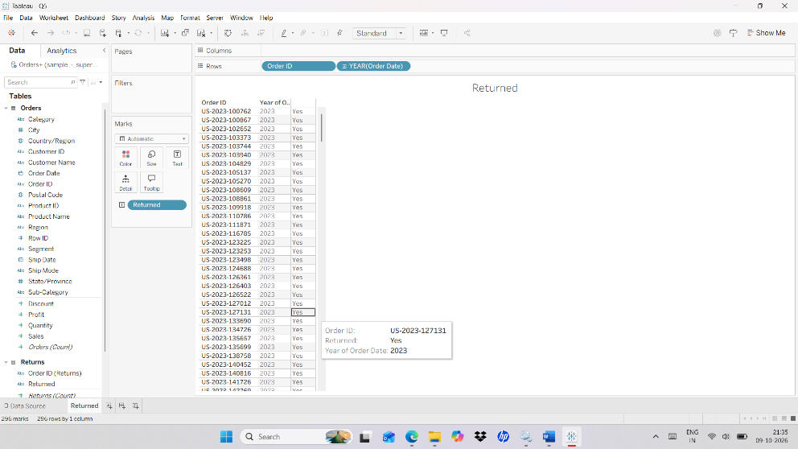
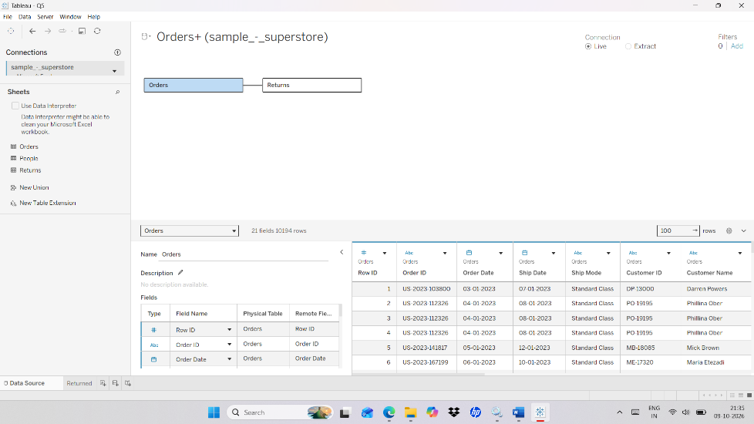

Q6. Combine Two Regional Sales Tables Using Union.

Steps :

- Connect to the Bookshop Dataset.
- In Data Source Click – New Union
- Drag two sales table.
- Click ok

Output :
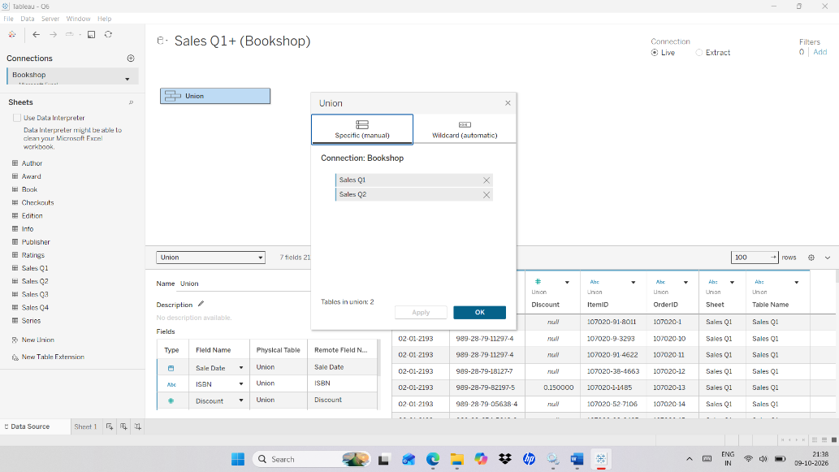

Q7. Display the data Handling Joins, on orders and return.

Steps :

- Connect to Superstore dataset.
- Drag Order table.
- Double click Order table - Drag Return table.
- Select the required Join Operation.

Output :
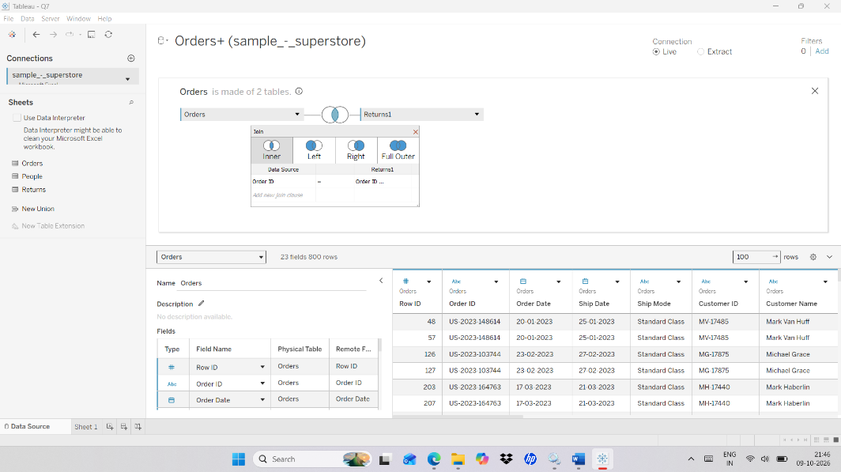

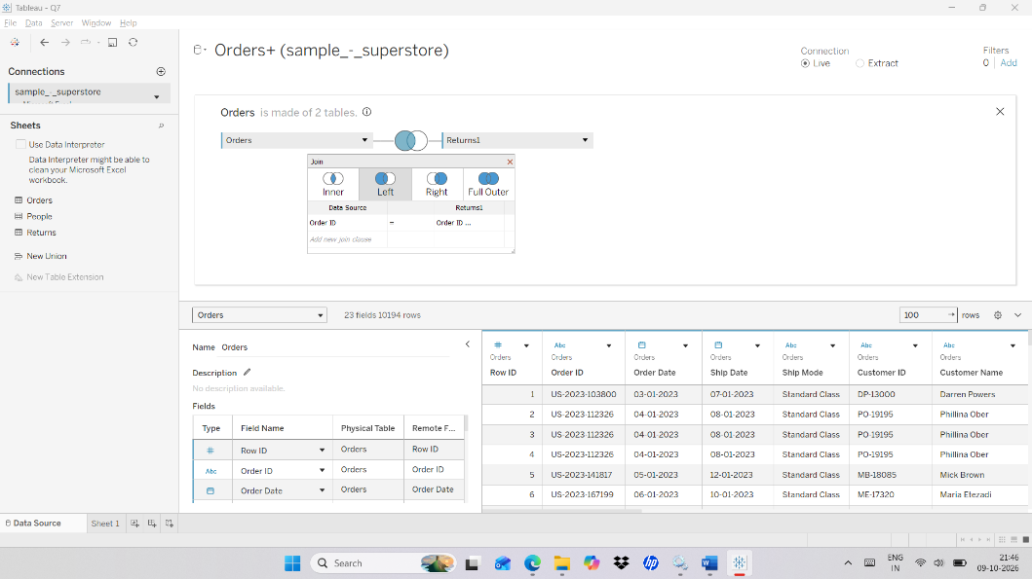

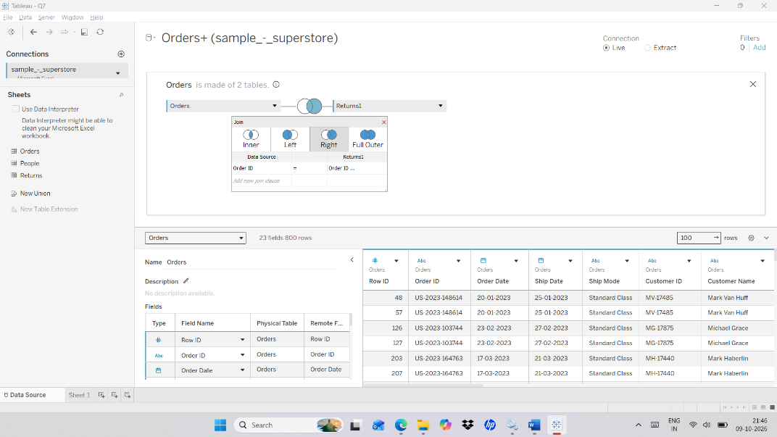

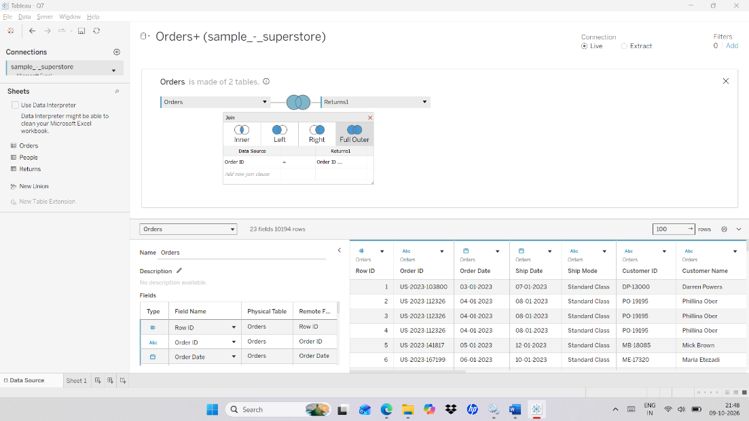

Q8. Find the first order date for every customer using an LOD expression.
Steps :

- Connect to Superstore dataset.
- Create Calculated Field - { FIXED [Customer ID] : MIN([Order Date]) }
- Drag Calculated field to text.
- Drag Customer name to rows.

Output :

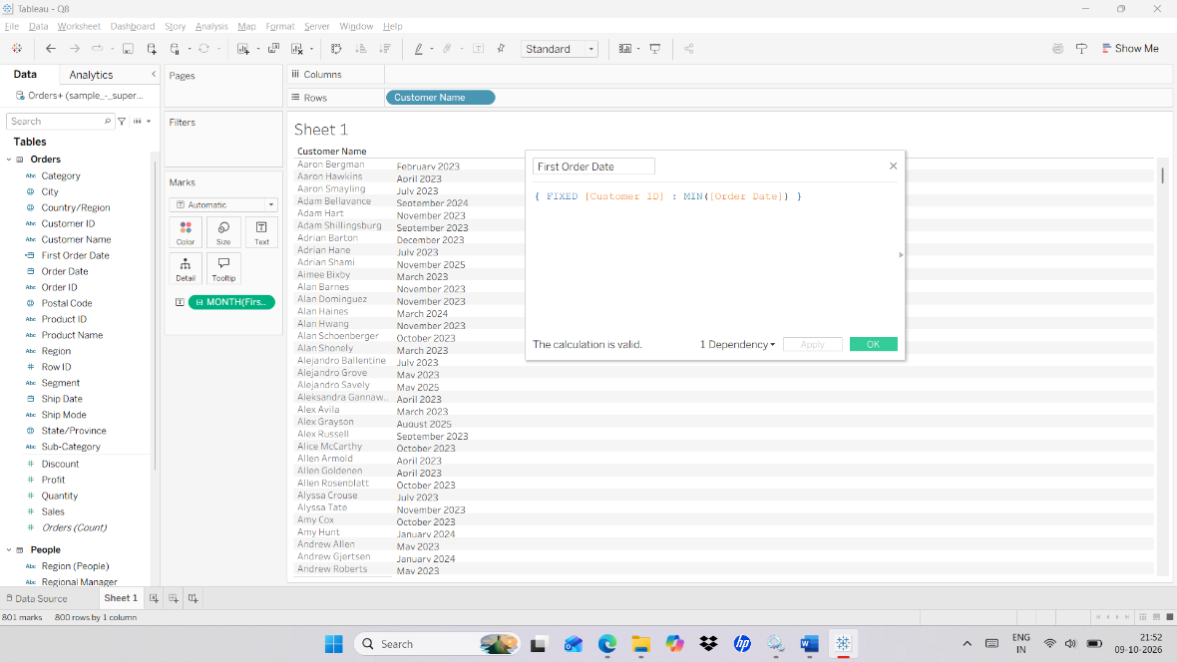

Q9. Calculate the average order value for each Region using LOD.

Steps :

- Connect to Superstore dataset.
- Create Calculated Field.
- Select Create Calculated Field - SUM([Profit]) / SUM([Sales])
- Click ok
- Drag Calculated Field to text in marks card.

Output :
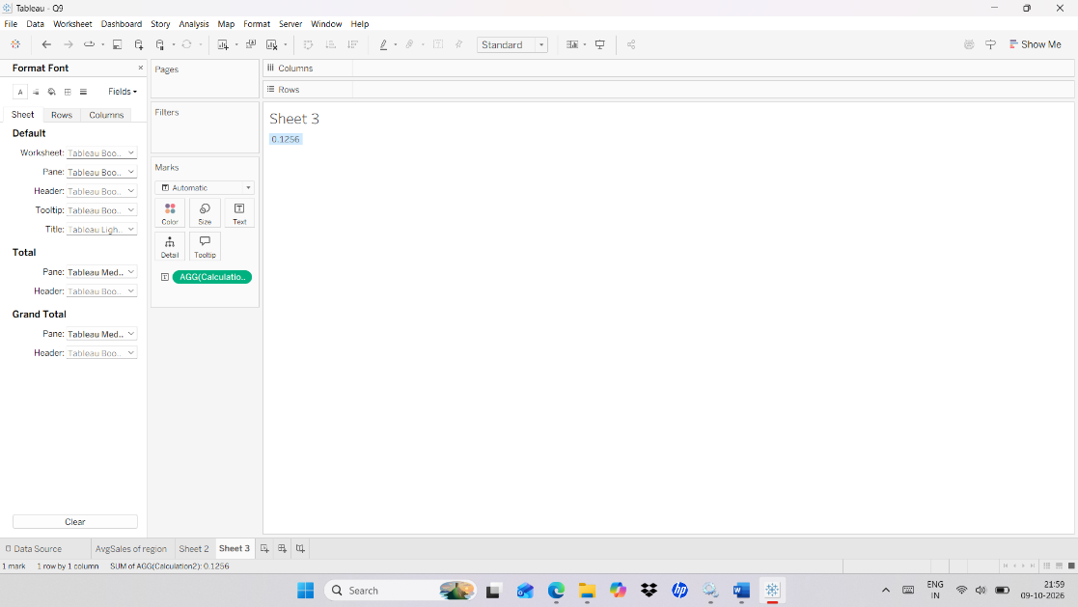

Q10. Create a Heat Map, Motion chart for Order date, and Product Forecast for sales with Trend Line.

Steps : Heat map

- Open a new worksheet and connect to Superstore.
- Drag Category - Text
- Drag Order Date(Month) -Text
- Drag Order Date(Yeat) - Text
- Drag Sales - Color.
- Drag Sales - Size.
- In Show me click Heat Map.

Output :

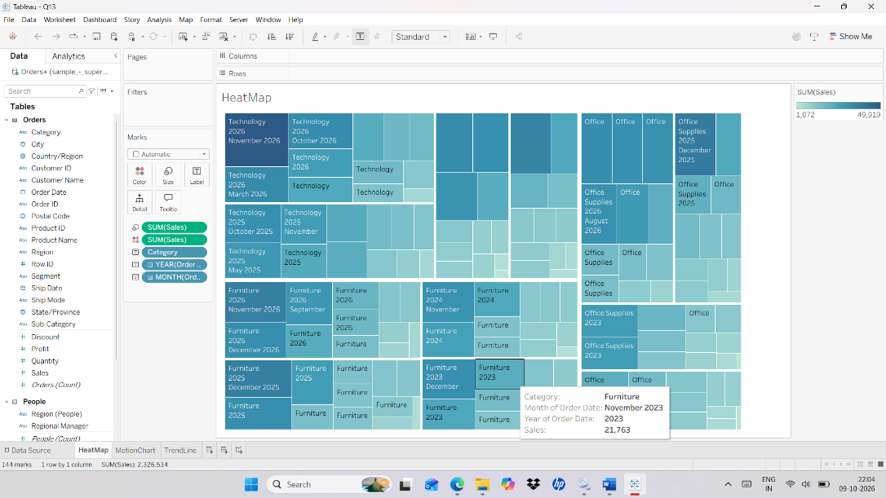

Steps : Motion Chart

- Open a new worksheet and rename it Motion Chart.
- Drag Order Date(Month) → Pages and color
- Drag Sales - Rows.
- Drag Category - rows
- Open the Pages card and click the Play button.

Output :
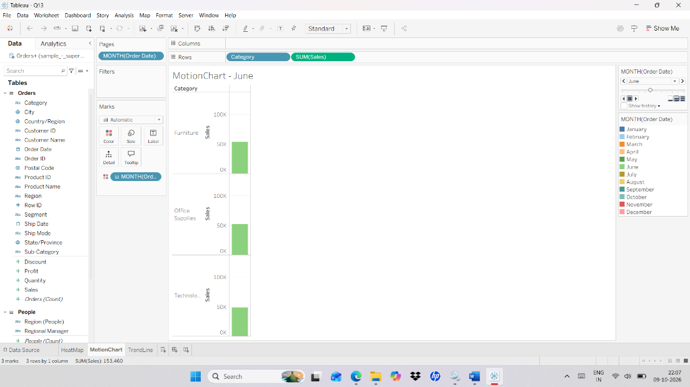

Steps : Trend Line with forecast.

- Connect to Superstore dataset.
- Drag Sales – rows.
- Drag Order Date – Column
- Select Month and Continuous for Order Date.
- Go to Analytics and select TrendLine and Forecast.

Output :
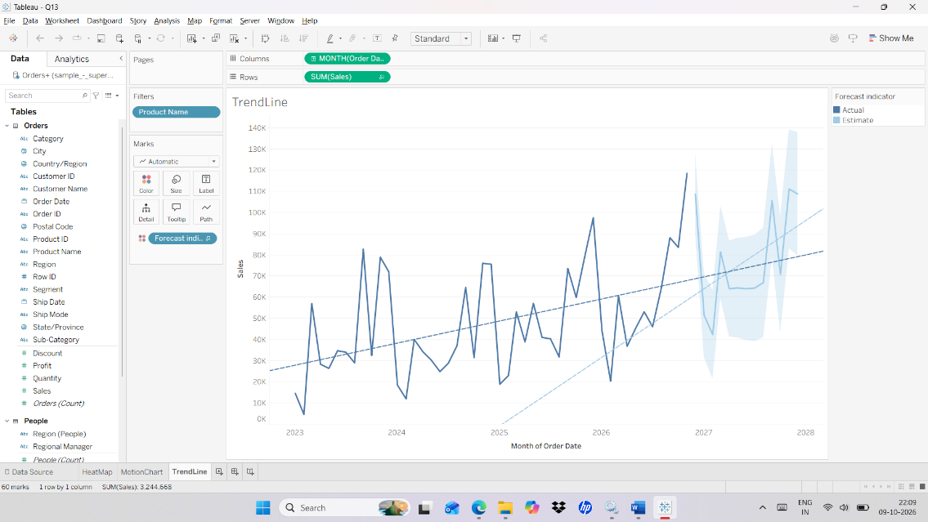

Q11. Create a Dashbaord as follows__
- Create KPI ‘s for Total_sales,Total_profit,Total_Discount.
- Report on Subcategory of product, region Wise Sales.
- Top 5 Customers in each region.
- Category wise sales and profit.
Steps : a) Create KPI ‘s for Total_sales,Total_profit,Total_Discount.

- Drag Sales to the sheet.
- Drag Profit to the sheet.
- Drag Discount to the sheet.

Output :
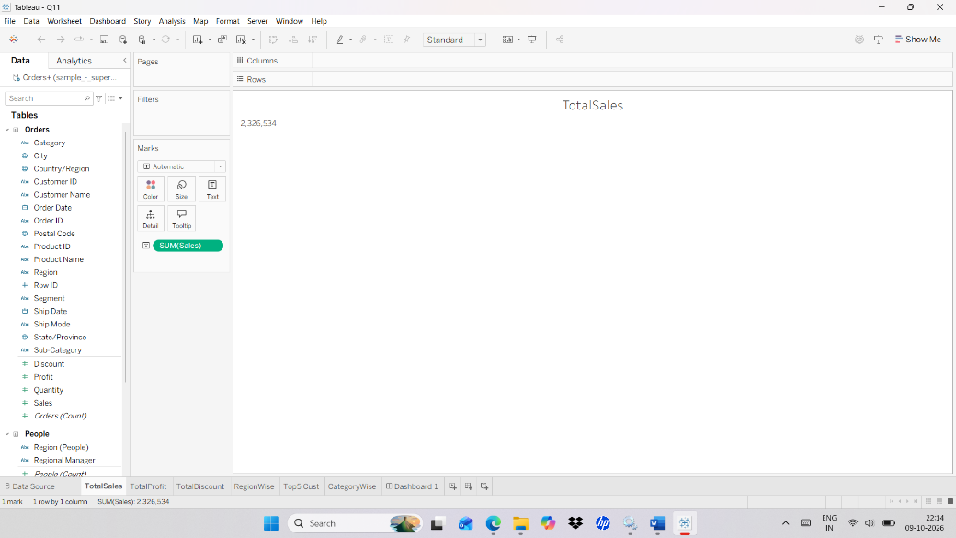

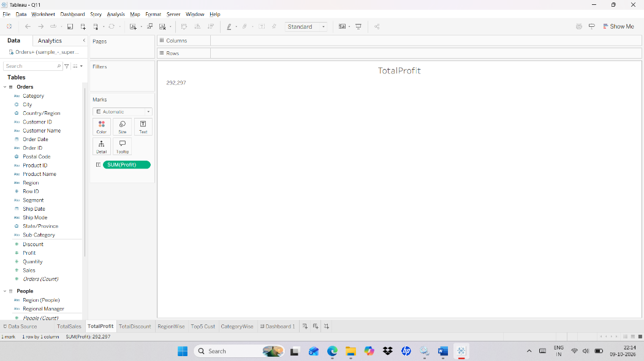

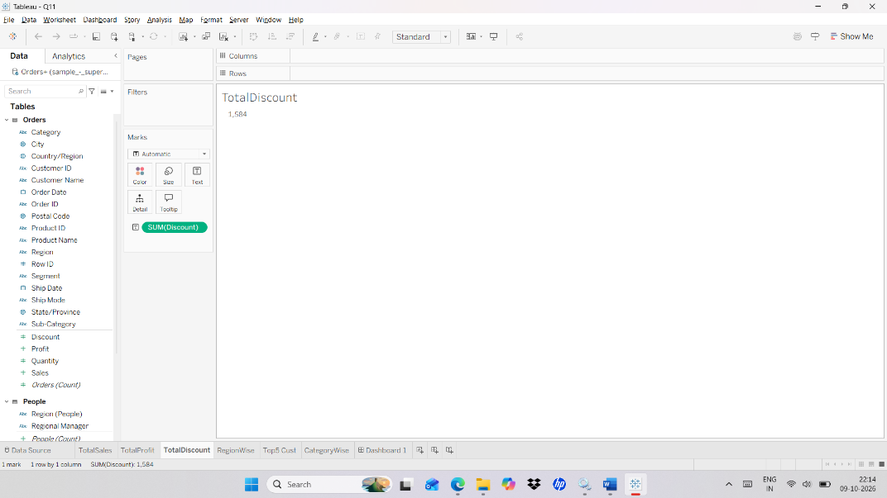

Steps : b) Report on Subcategory of product, region Wise Sales.

- Connect to Superstore dataset.
- Drag sub-category to rows.
- Drag Region to columns.
- Drag sales to number and color in marks card.

Output :
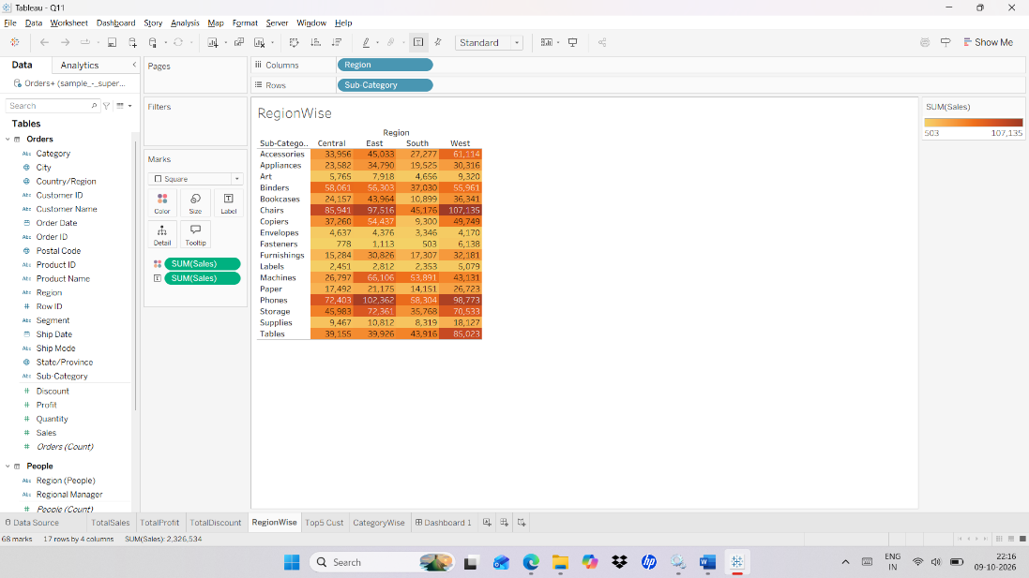

Steps : c) Top 5 Customers in each region.

- Connect to Superstore dataset.
- Create Calculated field - RANK(SUM([Sales]), 'desc')
- Drag Sales to columns.
- Drag Region to rows.
- Drag Customer name to rows.
- Drag calculated field to filter and edit table calculation.
- Select specific dimension – customer name.
- Click ok.

Output :

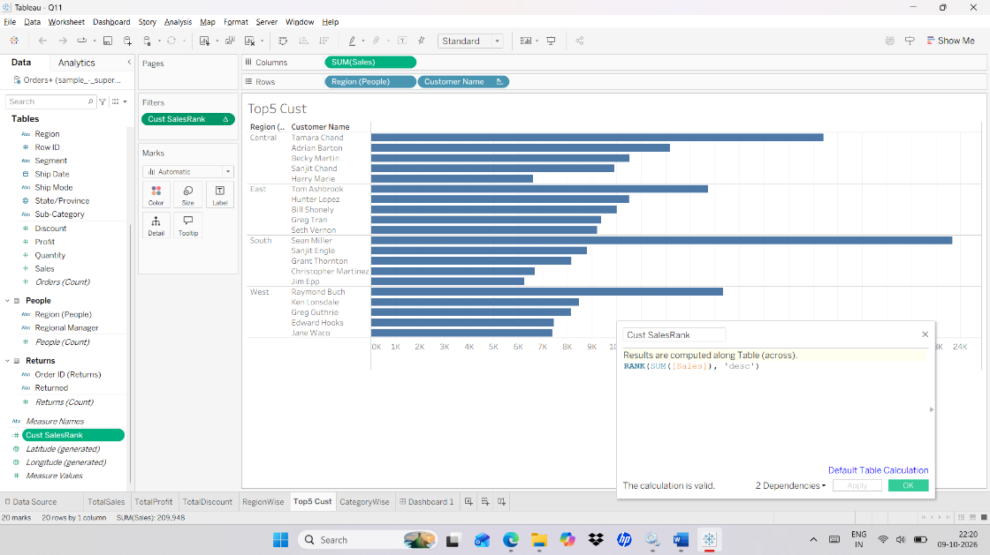

Steps : d) Category wise sales and profit.
- Connect to Superstore dataset.
- Drag Sales and Profit to rows
- Drag Region to rows.
- Drag Category to columns.

Output :
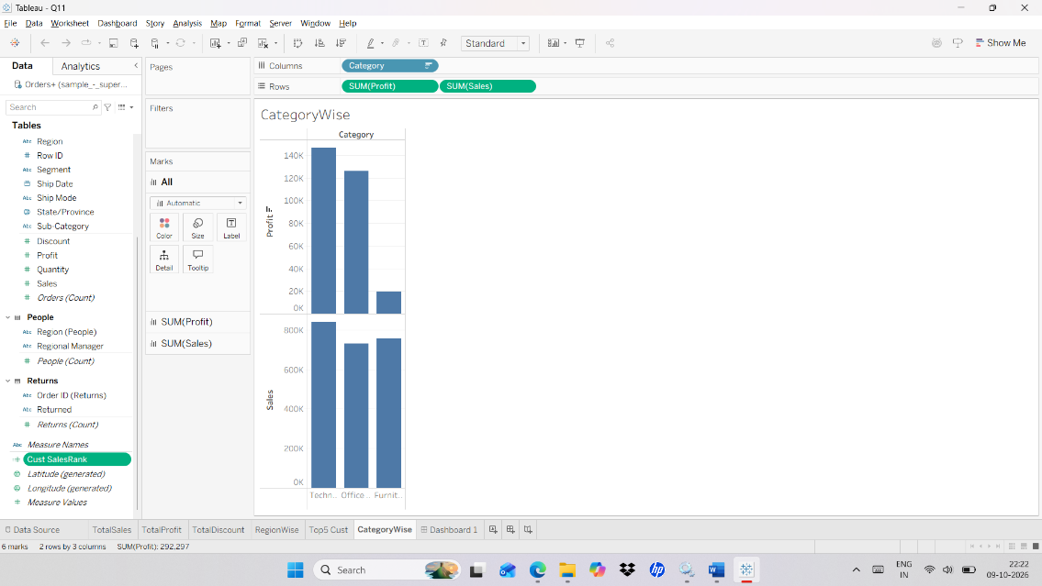

Steps : Dashboard

- Select Automatic for size.
- Select floating.
- Drag Sheets to the Dashboard.

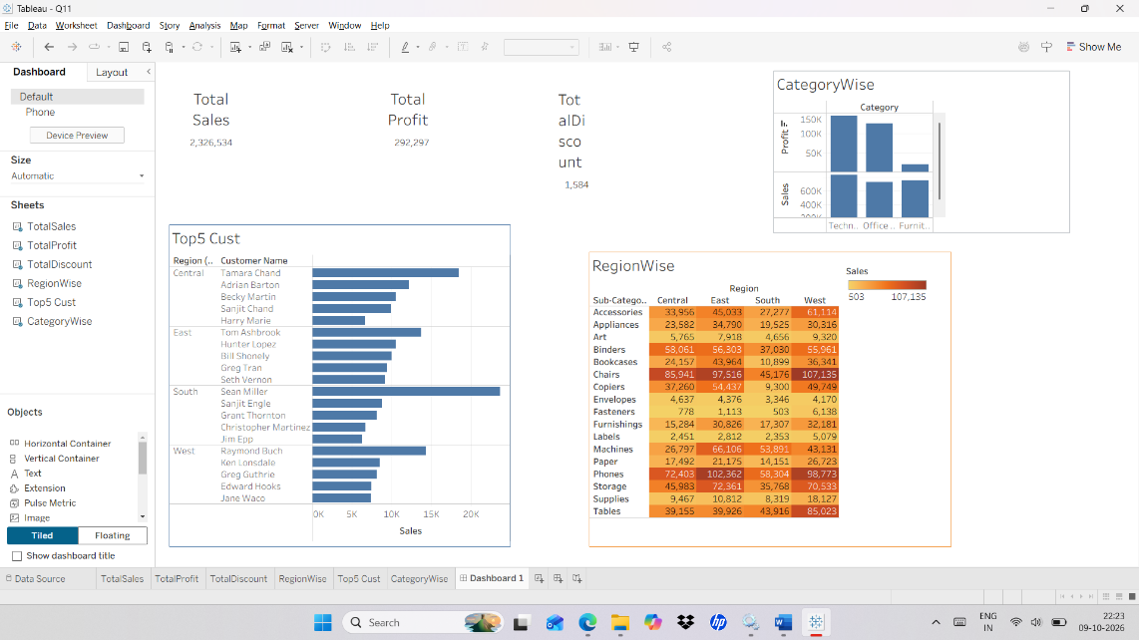

Q12. Create a dashboard Showing result such as follows-
Create an inventory monitoring dashboard as follows___
- Total Books
- Total Checkouts
- Checkout by Award
- Checkout by Book
Steps : Total books, Total checkout
- Drag Sales to the Sheet.
- Drag Checkouts to the Sheet.
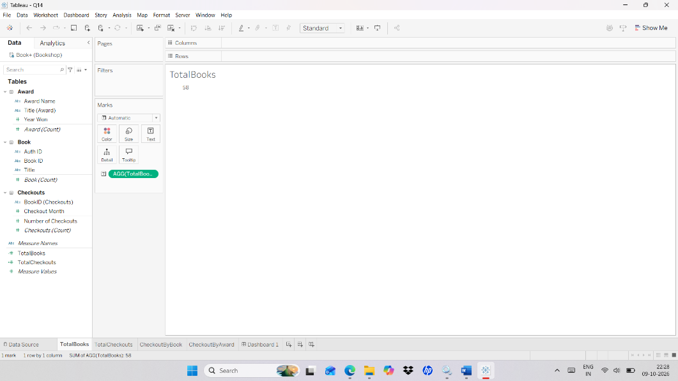
Output :

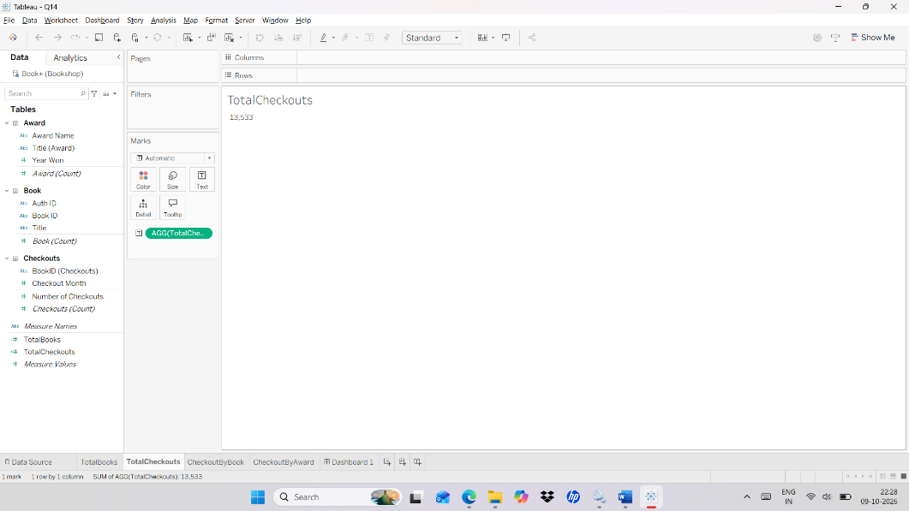

Steps : Checkout by Book

- Drag Checkouts to column.
- Drag Book title and Book ID to rows.

Output :
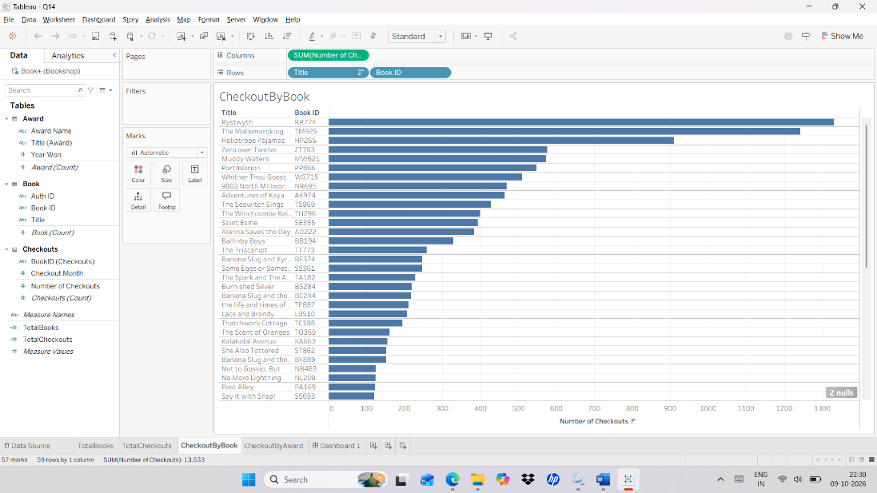

Steps : Checkout by Award

- Drag Checkouts to column.
- Drag Award name and Award title to rows.

Output :
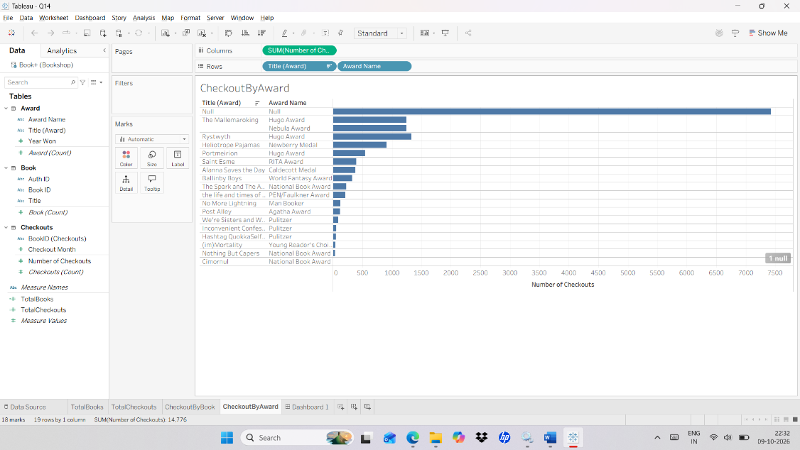

Steps : Dashboard

- Select Automatic for size.
- Select floating.
- Drag Sheets to the Dashboard.

Output :
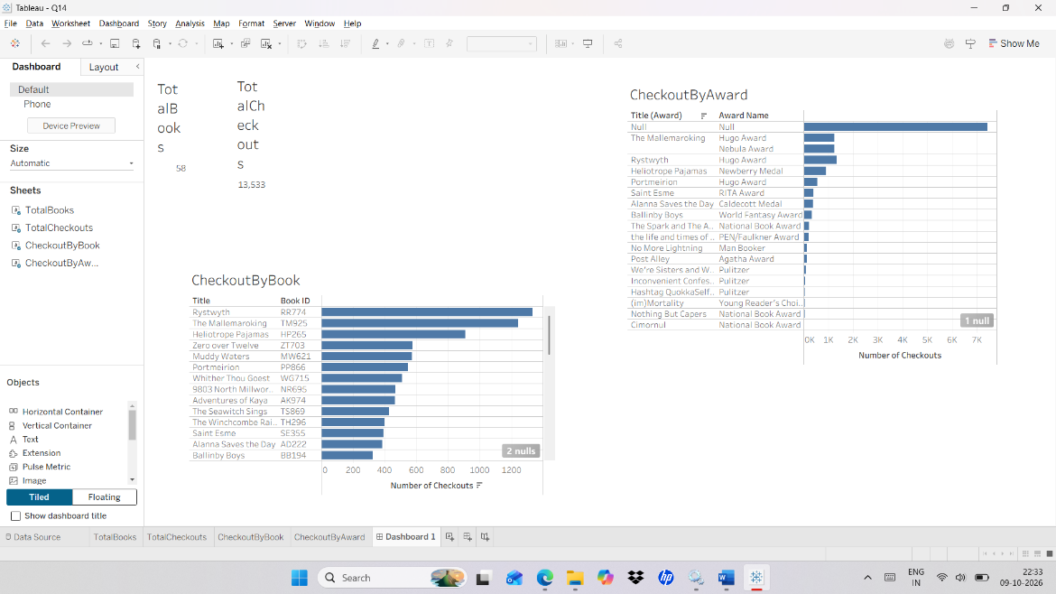

Q13. Create a Story using Superstore data source.

Steps :

- Create 3 worksheets.
- 1st worksheet Drag region and sales to column and sub-category to rows.
- 2nd worksheet Drag profit to column and sub-category and sales to rows.
- 3rd woksheet Drag sub-category and region to column and quantity to rows.
- Create a new story and drag all three sheets one by one.

Output :
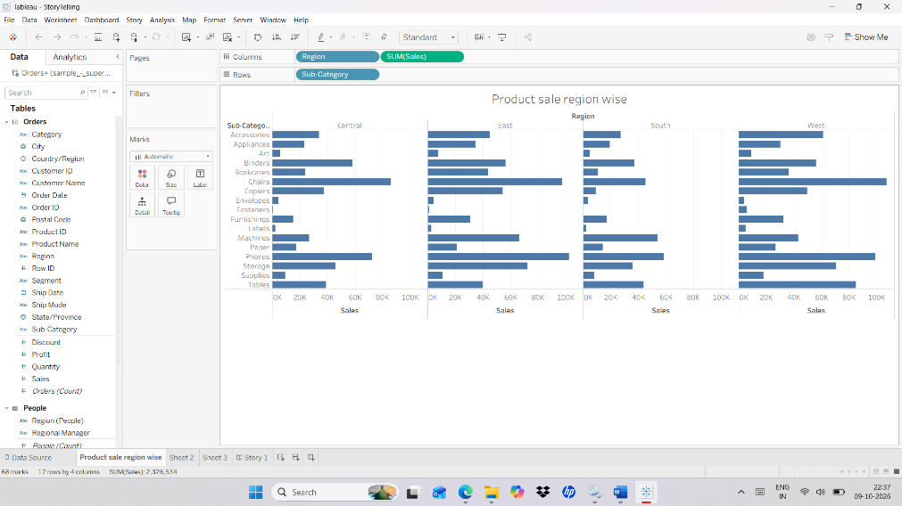

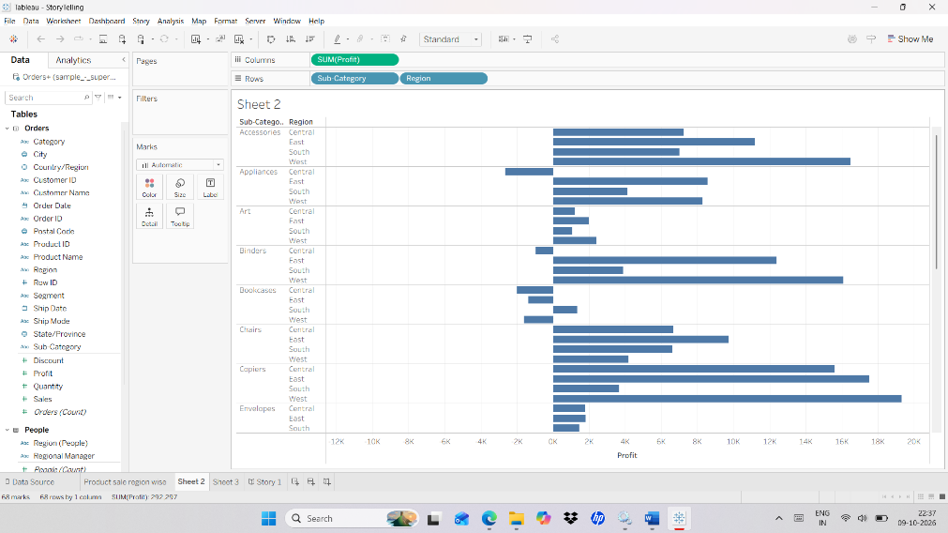

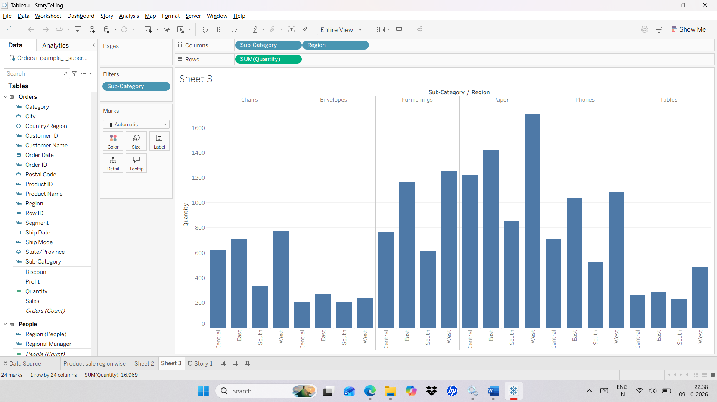

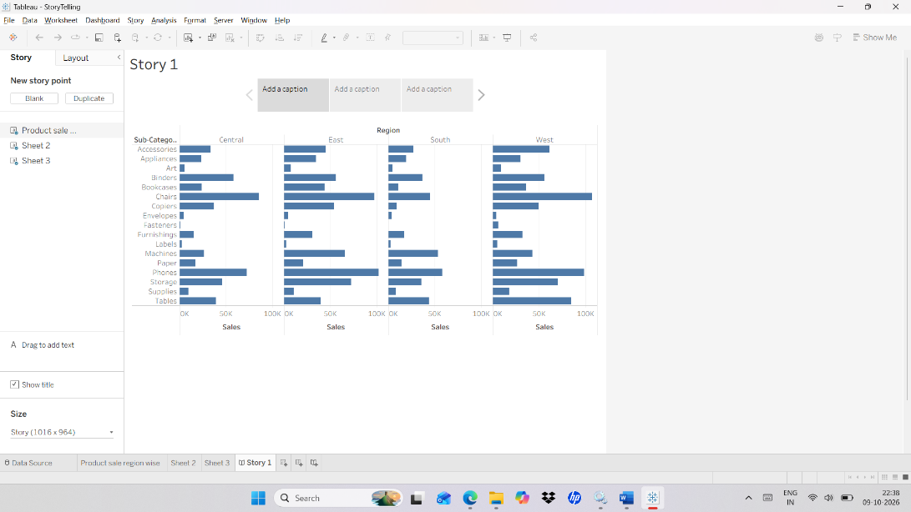

Q14. Implementation of Geographical Analysis.

Steps :

- Create new worksheet and connect to Superstore.
- Drag State to filters and in filter pane select all.
- Drag State to color.
- Drag longitude to column and latitude to rows.
- In show me select Geographical map.

Output :
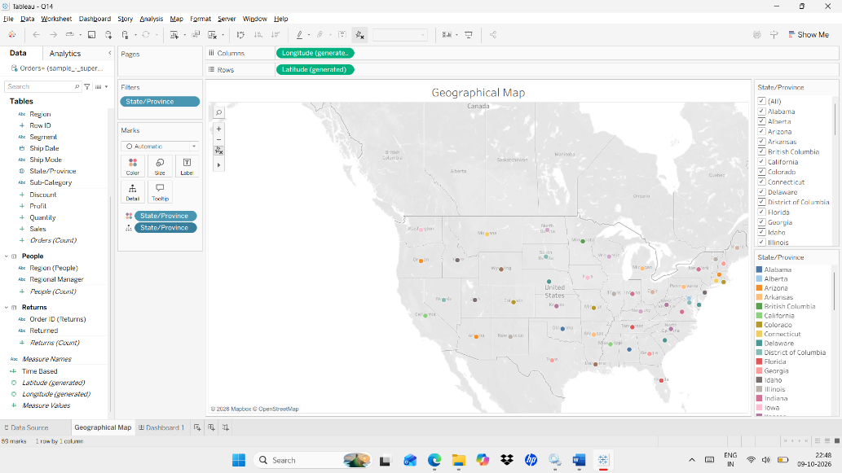

Steps : Dashboard

- Select Automatic for size.
- Select floating.
- Drag Sheets to the Dashboard.

Output :
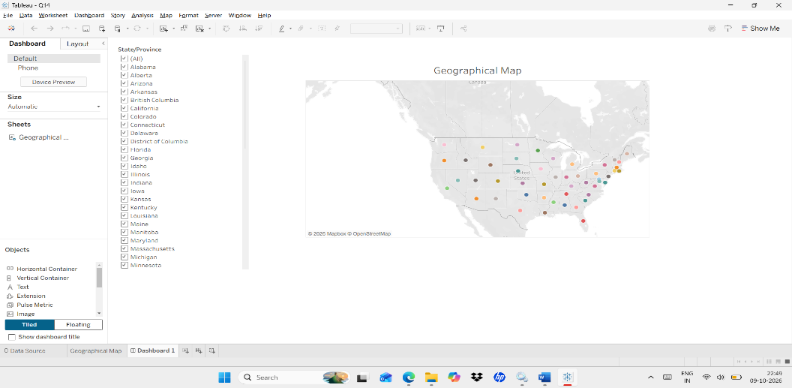

Q15. Create an interactive dashboard using superstore dataset show product trend line and forecast.
Steps : Trend Line with forecast.

- Connect to Superstore dataset.
- Drag Sales – rows.
- Drag Order Date – Column
- Select Month and Continuous for Order Date.
- Go to Analytics and select TrendLine and Forecast
- Drag Region, Category and Segment to filters.

Output :
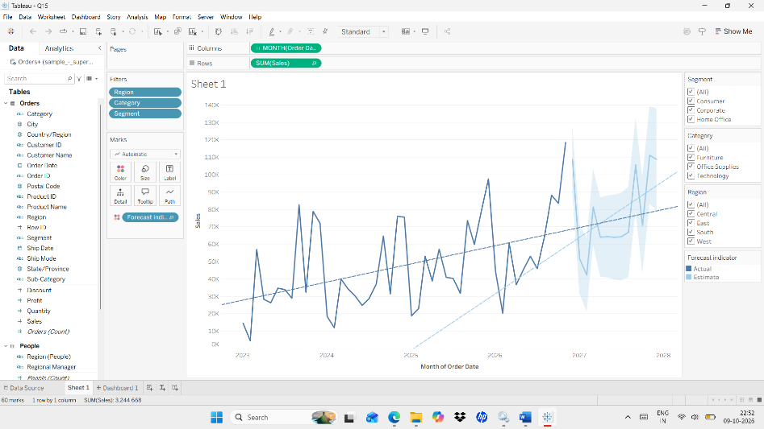

Steps : Dashboard

- Select Automatic for size.
- Select floating.
- Drag Sheets to the Dashboard.

Output :
